Dolphins
Childcare

Welcome pack

Dolphins Childcare Mission statement
To provide a happy, safe, enthusiastic and stimulating environment for all children to play, learn and develop freely.

To support all families by working together in partnership to ensure every child has the opportunity to develop and achieve their early learning goals.

__________________________________________

Please bring in a picture of you and your child to put on the family wall so the children can feel comfort with a link from home to nursery.

Dolphins Childcare Price List

Registration Fee = £40 [book bag and t-shirt included]
Am session 8.30-11.30am = £17.00

Lunch club 11.30-12.00pm = £2
[you will provide your child’s own lunch in a lunch box]

Pm session 12.00-15.00pm = £17.00

Extra hours = £7.00 per hour

Uniform
Dolphins jumper = £9.00
T shirt = £6.50
Bookbag = £6.00

Things we lend….

Activity bags
We have a range of different activity bags that we send home. These bags are to share with your child for the week e.g. story bag, song bag, multi-sensory bag and physical play bag.
We hope you enjoys these activities and we ask if you could keep them in the same condition you received them in. We would really appreciate your feedback on the sheet provided inside along with the date the bag has to be returned.

Splash bag
Splash is our pet Dolphin that lives in the setting with us. We allow children to take it home in a special bag each week and see what adventures he gets up to so we can share it in our Splash book for all of the children to use in the setting.

Book bags
Children will have an allocated book day where they will have the opportunity to change their book from a selection in the nursery. We do not expect them to read the book themselves but just to share it with you looking at and talking about the pictures etc. We will fill in the reading record and there are spaces for your comments.

Parents / Carers Library
Outside we have the parent trolley, on this is a selection of books that you can borrow we have books for children and books for adults. Please help yourself and fill in the sheet to say what book/s you have taken.
Please come and ask if you have any questions.

Scooter Club
We offer your child the opportunity to have a scooter for the week. We provide the scooter, high vis jacket and helmet for safety.
As we offer this service free of charge, we expect you to take good care of the scooters and equipment that is given.

Parent support and Parent activities
We have a number of opportunities for parents to come and help support the setting. This could be for 10/15 minutes, a session or a full day………

- Religious festivals & celebrations - Please come in and share your religious festival with us. Come and show, talk or share/cook religious food with us. Any days and times that suit you, we will be happy to have you in.
- Share your job – Please come in and talk about your job with the children. Spend some time with us explaining what you do, bring in props/tools from your job and maybe let the children have a turn in what you do.
- Come in and help days – Please come in and have snack with your child, teddy bears picnic or read stories with us.
- Parent helpers – We always like to have parent volunteers, where you can come in for a session and help support the children in their everyday activities.
- Parent Focus groups – This will be a session based around a focus topic that will give ideas, techniques and strategies on how to carry out things in the best way.
- Come and play days / Festive come and play days – This will give you the opportunity to come and see what your child gest up to and what they are learning about.
- Parent consultations – These are short meetings with your child’s key person, to explain how your child’s progressing and to have a look at their learning journals with us.

Things to remember
Show and tell days
children will have the opportunity to bring in something from home e.g. toy, pictures, something from a trip, something from their journey to nursery etc. They will spend a few minutes sharing this with the group. Show and tell is on TUESDAYS AND FRIDAYS ONLY.

Home communication books
Please bring your home communication books daily and leave them in the box on parent trolley. Using these daily will give you and update of what your child’s been up to on the day and anything else you may want to know.

Coming in on time
Please try your best to get to nursery on time. We have an important time at the beginning of each session called ‘FOCUS’. The children learn about numbers, days of the week and the weather, show and tell is also during this time.

Clothing
Please don’t dress your child in new clothes as they may get messy through play. If you would like to leave a pair of wellies here for our mud kitchen and muddy puddles please bring in a named pair and we will store them here for your child.

Dolphins Childcare (Please bring back to nursery)
below are pictures of different technology appliances please could you let us know what your child is able to do on them if they do not have access to an item that is totally fine please just write ‘no access’ this information will be fed into your child’s Learning Journal
Thank you for your help and support it is greatly appreciated by the staff.
Mobile phone – What do you go on and how long do you use it.
Ipad – What do you go on and how long do you use it.

Games console – What do you go on and how long do you use it.
PC / Laptop – What do you go on and how long do you use it.

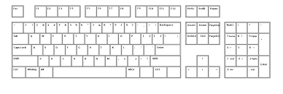

All About Me at Home Name__________________ (Please bring back to nursery)

My favourite toy
What I like to do at home…

My family are…
I like to eat…

A little bit about me…

If English is your child’s second language, please fill out this sheet
So we can help support you child in the best possible way.
My first language is……………………………………………………………
(Please bring back to nursery)
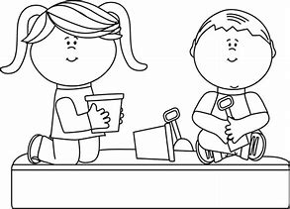
Here are some words to help me at Dolphins

eat
___________

play
___________

nappy
___________

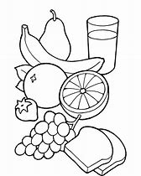
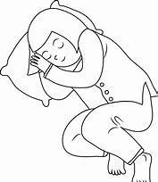
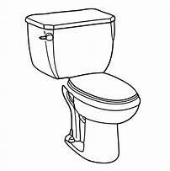

Tired / sleep
___________

Snack / food
___________

toilet
___________

home
___________

drink
___________

